Favorite Movie App

Table of Contents

− 3rd Party!: 3

− Project structure: 4

• FavMovies.DataStore.Abstactions 5

• FAVMOVIES.DATASTORE.CLOUD 6

• FAVMOVIES.DATASTORE.MOCK 7

• FavMovies.DataObjects 8

• FavMovies.Clients.Portable 9

• FavMovies.Clients.UI 10

• FavMovies.Utils 11

• FavMovies.Android 12

• FavMovies.iOS 13

− SCREENSHOTS (Android) 14

• Movies 14

• Top Rated Movies 15

• Popular Movies 16

• Now Playing Movies 17

• Movie Detail 18

− Screenshots (ios) 19)

• Movies 19

• Top Rated Movies 20

• Popular Movies 21

• Now Playing Movies 22

• Movie Detail 23

# 3rd Party:

1. Xamarin Forms 2.3.4.247

Well!!!! ….For Cross Platform Development

1. Acr.Userdialogs 6.4.1

Display POP Ups and Other Notifications like Toast

1. AsNum.Xfcontrols 1.0.0.6

Many useful controls, used repeater from this 3rd party

1. Dltookit Flowlist View 2.0.4

Extended Forms List View

1. FF ImageLoading 2.2.8

Maintaining image caches.

1. GalaSoft MvvmLight 5.3.0

MVVM framework Implementation

1. NewtonSoft.JSON 10.0.3

Convert JSON to Data Objects

1. Rg Plugins 1.0.4

Open pages in popup.We have used this for displaying Movie Detail and Video Play Page.

1. Plugins Settings 2.5.8

To persist Favorites between sessions

1. XamForms Pull To Refresh 1.1.0
2. Plugins Permission 1.2.1

For future use

1. Plugins Media 2.6.2

For future use

1. Plugins CurrentActivity 1.0.1

For future use

# Project structure:

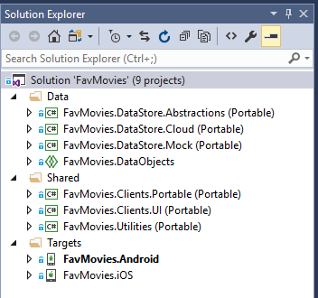

## FavMovies.DataStore.Abstactions

Data Service layer abstraction, really helps with the separation of backend and front-end development

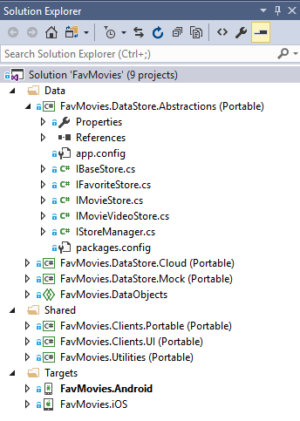

1. IBaseStore: Base Interface for all the interfaces
2. IFavoriteStore
3. IMovieStore
4. IMovieVideoStore
5. IStoreManager

## FAVMOVIES.DATASTORE.CLOUD

Data service layer, HTTP Cloud API provider implementation

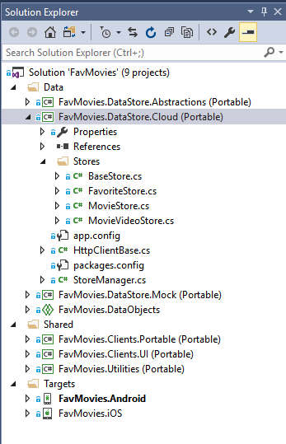

1. BaseStore
2. FavoriteStore
3. MovieStore
4. MovieVideoStore
5. HttpClientBase
6. StoreManager

## FAVMOVIES.DATASTORE.MOCK

Data service layer, Mock data provider implementation

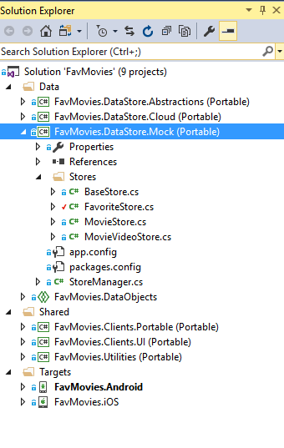

1. BaseStore
2. FavoriteStore
3. MovieStore
4. MovieVideoStore
5. HttpClientBase
6. StoreManager

## FavMovies.DataObjects

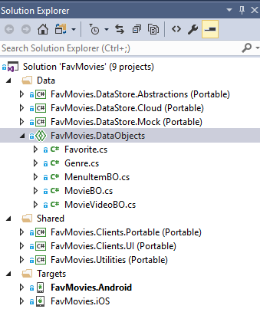

This class library contains the data models.

1. Favorite
2. Genre
3. MenuItemBO
4. MovieBO
5. MovieVIdeoBO

## FavMovies.Clients.Portable

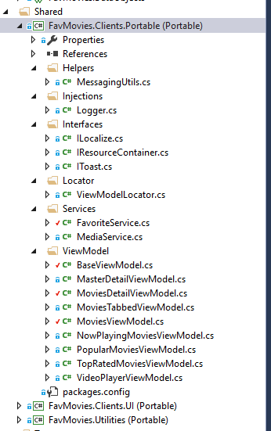

1. MessagingUtils.cs: Local subscription based messaging
2. Logger.cs : Shared logging implementation
3. ILocalize.cs : Support multiple languages
4. IResourceContatiner.cs
5. IToast.cs: Platform agnostic toasts
6. ViewModelLocator: Static strings, views with their associated ViewModels
7. All ViewModels Folder : Folder houses all the ViewModels.

## FavMovies.Clients.UI

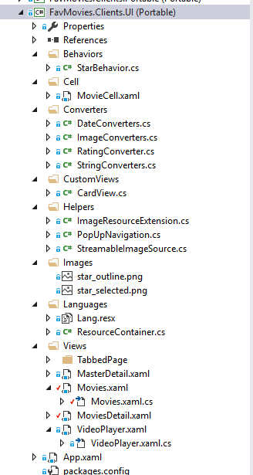

1. StarBehavior.cs: Rating management behavior – for future use
2. MovieCell.xaml : Movie Cell DataTemplate type which is used in the list views.
3. Convertors (Folder) :
4. CardView.cs: Tinder style carousel – for future use
5. Helpers (Folder)
6. Images (Folder)
7. Languages( Folder)
8. Views (Folder) : Contains UI for the App.
9. App.xaml : Starting point of the App.

## FavMovies.Utils

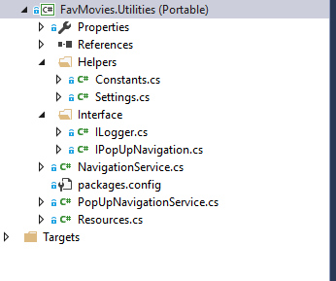

1. Helpers (Folder)
2. Interface (Folder)
3. NavigationService.cs : Inherited from INavigationService, implements Navigation for the App.
4. PopUpNavigationService.cs: Navigation service for PopUps.
5. Resources.cs

## FavMovies.Android

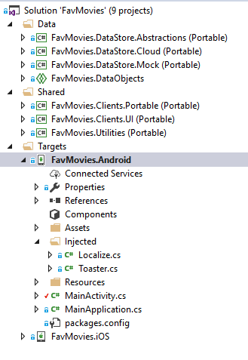

1. Assets (Folder) : Not used
2. Injected (Folder) : Implementations of some Interfaces declared in Portable Projects.
3. Resources (Folder): Store different platform specific images.
4. MainActivity.cs: Main Class of the Android Project.
5. MainApplication.cs

## FavMovies.iOS

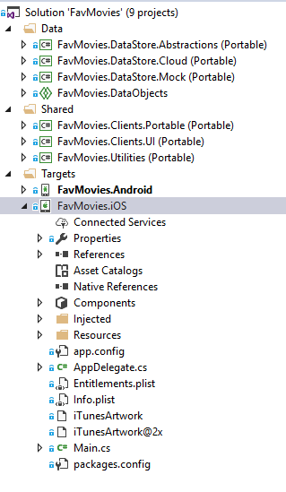

1. Injected(Folder) : Implementations of some of the Interfaces decalred in Portable Projects.
2. Resources (Folder) ): Store different platform specific images.
3. AppDelegate.cs:Main Class of iOS project
4. Main.cs

# SCREENSHOTS (Android)

## Main Menu

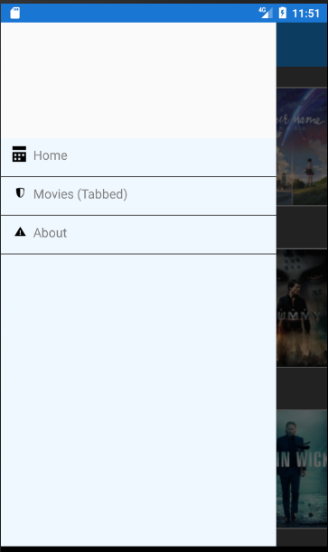

## All Movies – Home Page

FFImageLoading’s excellent caching, pull to refresh all work

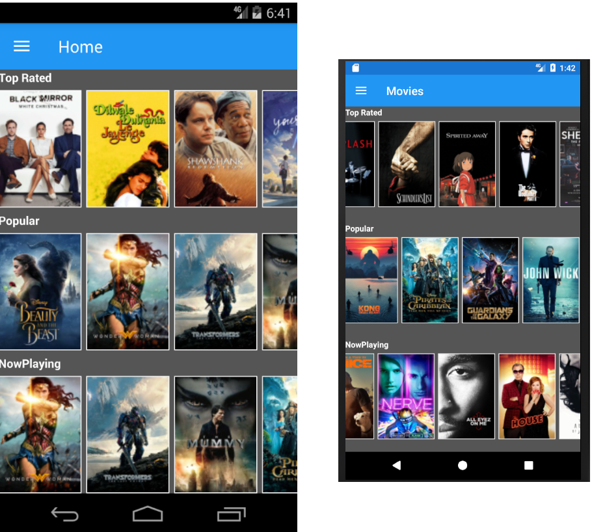

## Top Rated Movies (Tabbed Page)

DLToolkit.Forms.Controls.FlowListView combined with FFImageLoading’s excellent caching

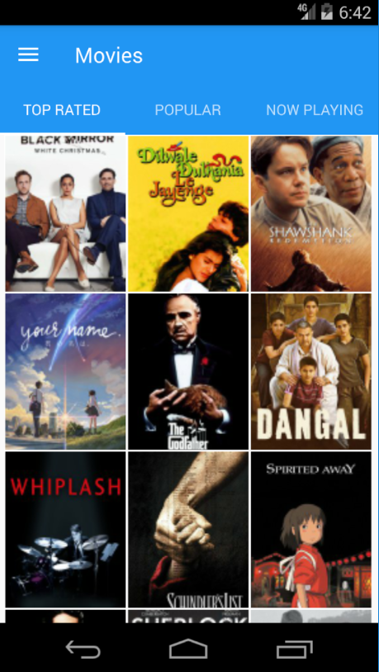

## Popular Movies (Tabbed Page)

DLToolkit.Forms.Controls.FlowListView combined with FFImageLoading’s excellent caching

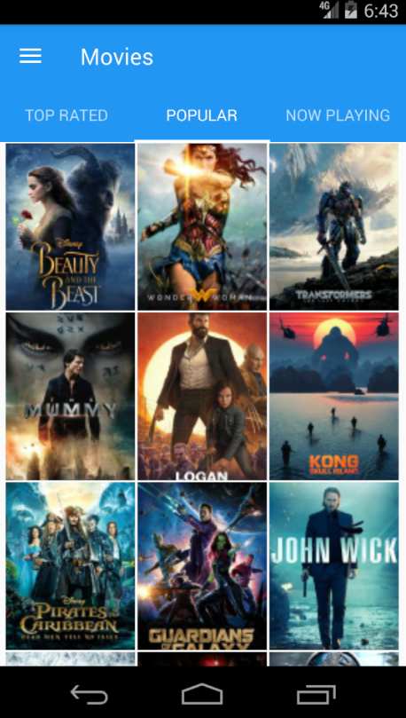

## Now Playing Movies (Tabbed Page)

DLToolkit.Forms.Controls.FlowListView combined with FFImageLoading’s excellent caching

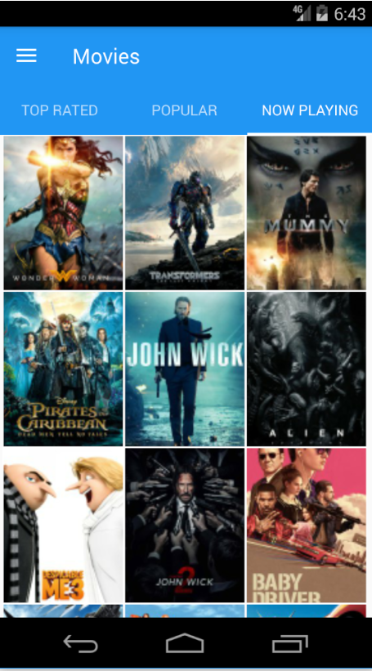

## Movie Detail (Popup)

Animated popup extended from Rg.Plugins.Popup.Pages.PopupPage. Scrollable similar movies bar and sticky ‘Save to Favorites’

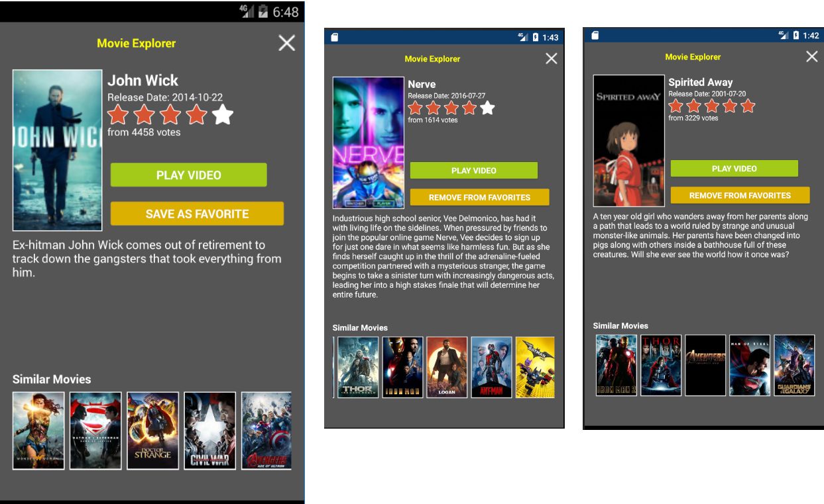

# Screenshots (ios)

## Main Menu

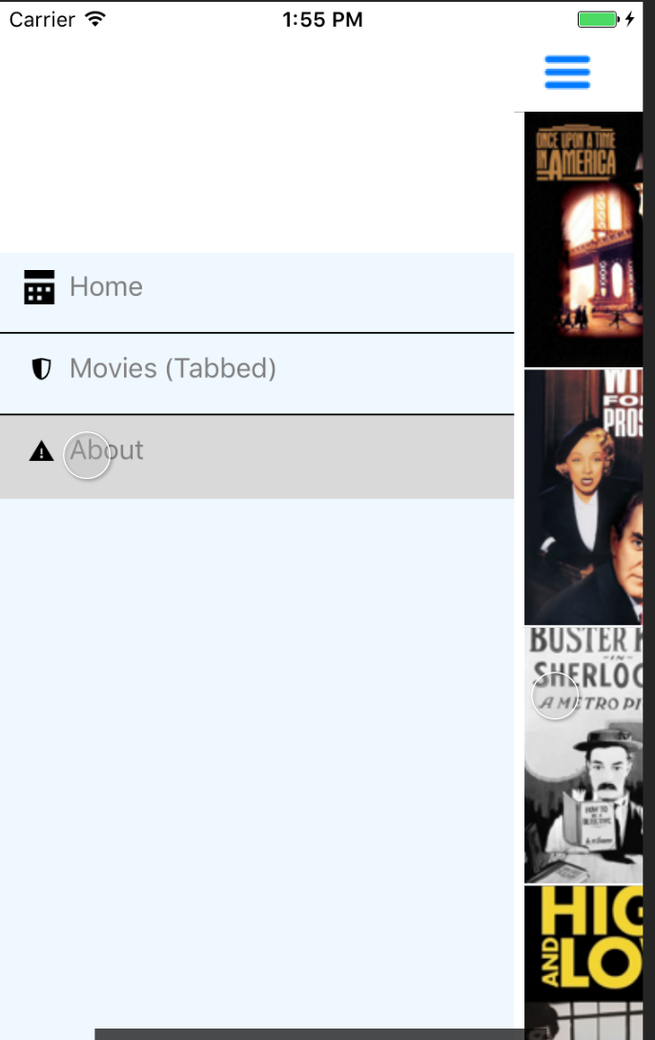

## All Movies (Home Page)

FFImageLoading’s excellent caching, pull to refresh all work

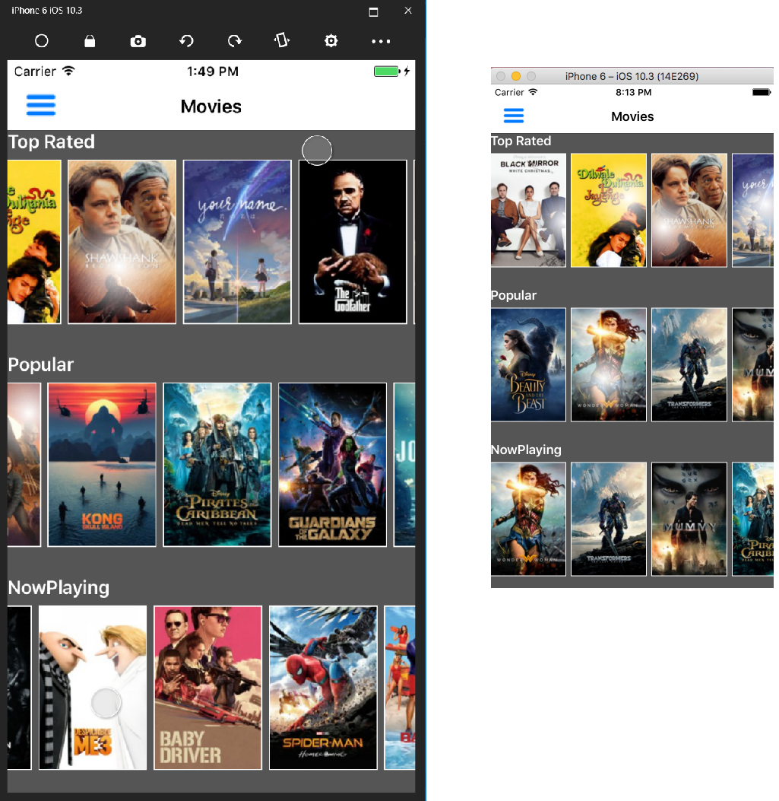

## Top Rated Movies (Tabbed Page)

DLToolkit.Forms.Controls.FlowListView combined with FFImageLoading’s excellent caching

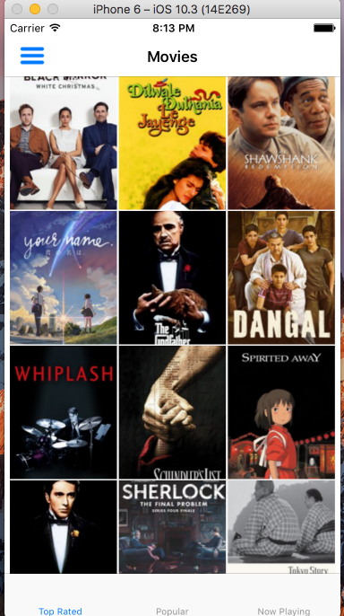

## Popular Movies (Tabbed Page)

DLToolkit.Forms.Controls.FlowListView combined with FFImageLoading’s excellent caching

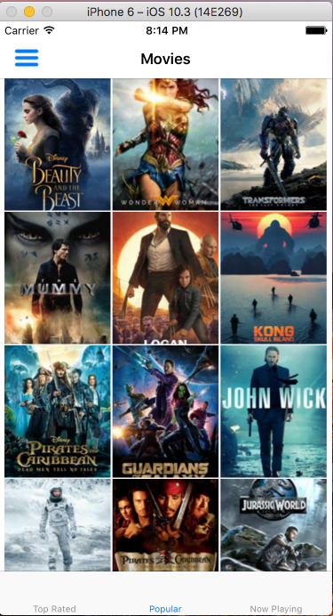

## Now Playing Movies (Tabbed Page)

DLToolkit.Forms.Controls.FlowListView combined with FFImageLoading’s excellent caching

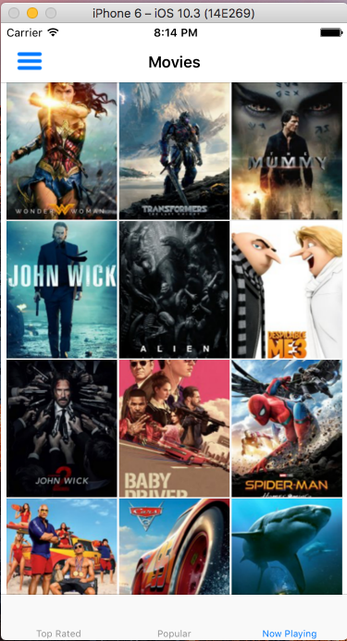

## Movie Detail (Popup)

Animated popup extended from Rg.Plugins.Popup.Pages.PopupPage. Scrollable similar movies bar and sticky ‘Save to Favorites’

